Database/Data Warehouse Ch.4 Problems

1. ERD:

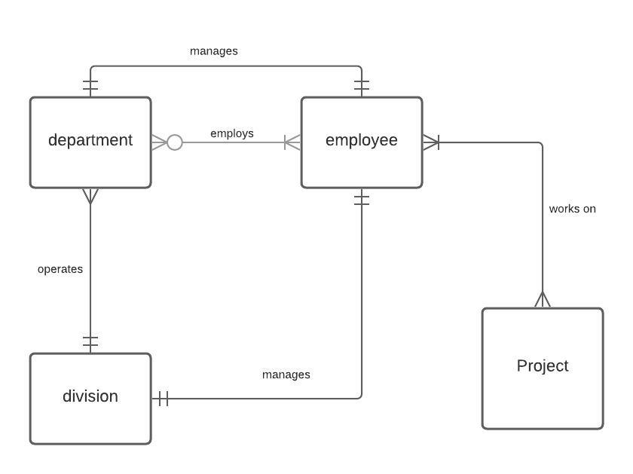

1. 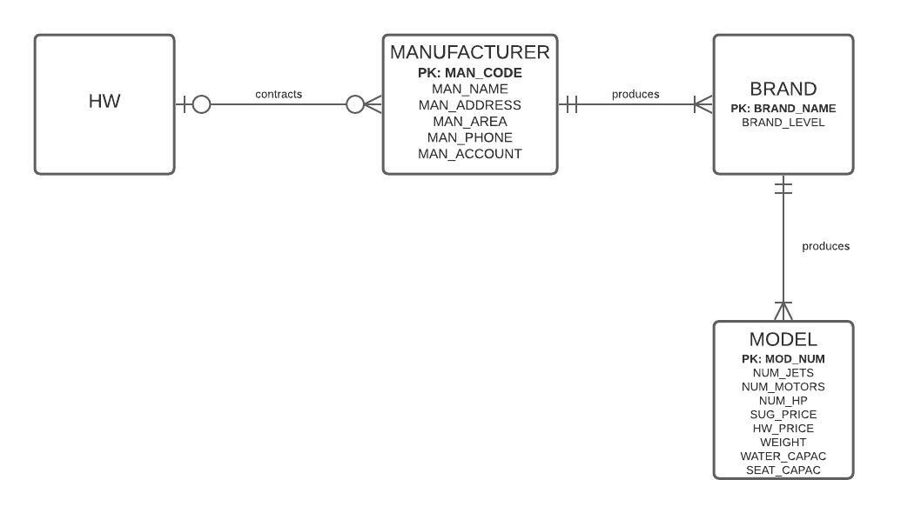ERD:
2. Questions:
   1. Connectivity:
      1. Each county may have multiple cities, but each city belongs to one county
      2. Each city may have one team, and each team belongs to one city
      3. Each team may have multiple players, but each player belongs to one team
      4. Each team may have multiple coaches, but each coach belongs to one team
      5. Teams may play multiple games, but each team only has one designation (home or away) per game
   2. TEAM is existent-dependent on CITY
   3. A team may have up to 12 players, but a minimum of 9 players (9,12); Each city may have up to one team, or no team at all (0,1).
   4. COACH is existent-dependent on TEAM. PLAYER is existent-independent of TEAM, but TEAM is existent-dependent on PLAYER.
   5. 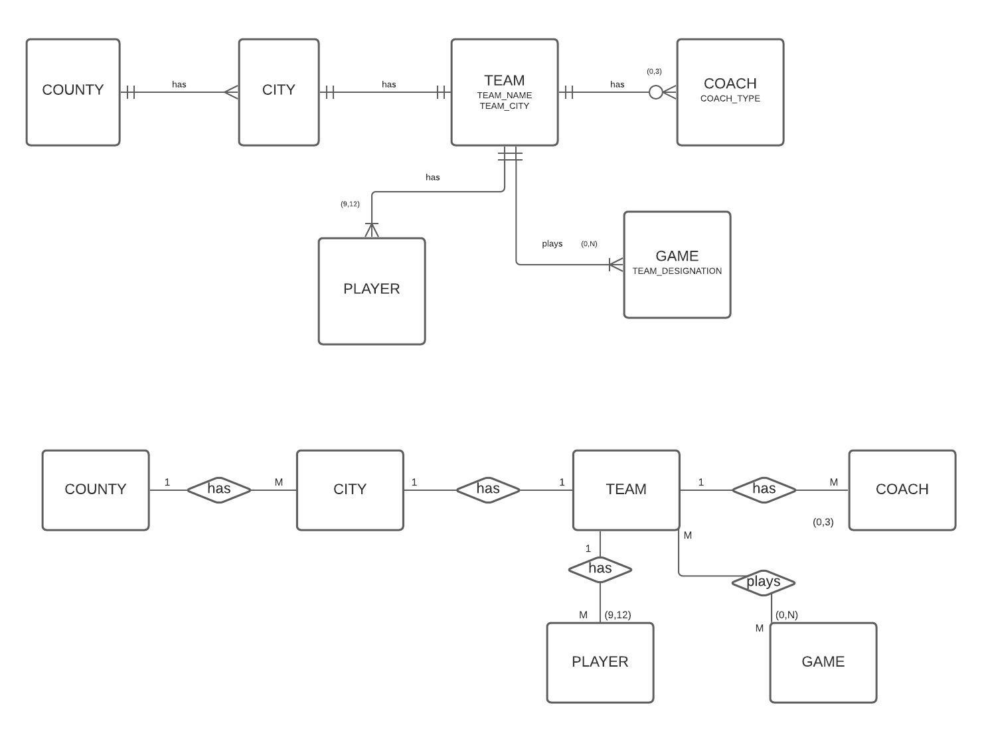Diagrams:

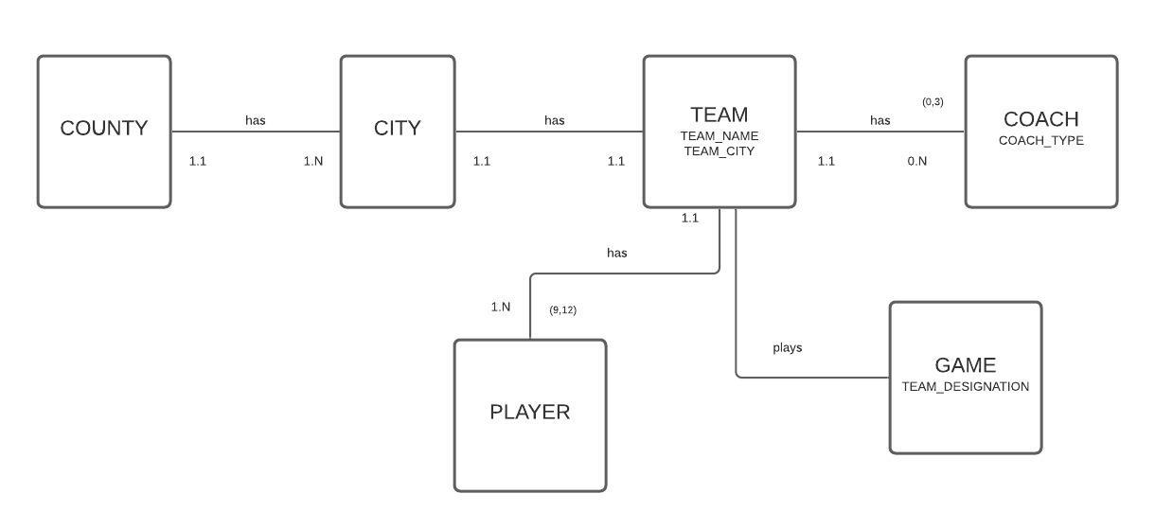

1. 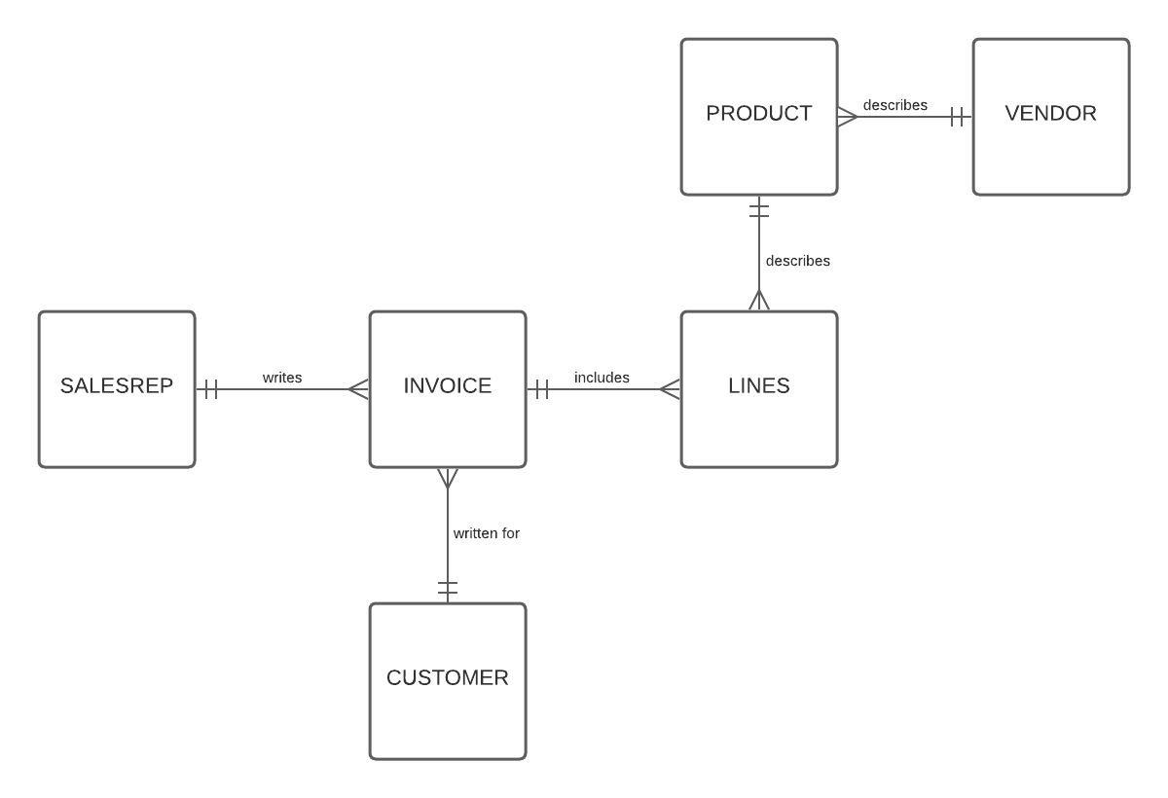Diagram:
2. Questions:

|  |  |  |  |
| --- | --- | --- | --- |
| ENTITY | RELATIONSHIP | CONNECTIVITY | ENTITY |
| INSTRUCTOR | teaches | 1:M | TRAINEES |
| COURSE | generates | 1:M | CLASS |
| HEG | offers | 1:M | COURSE |
| INSTRUCTOR | teaches | 1:M | CLASS |
| TRAINEE | enrolls in | M:N | CLASS |

* 1. An instructor may teach multiple classes, but each class is only taught by one instructor. An instructor’s cardinality in reference to classes is (0,2), meaning that a professor may teach up to 2 classes or not teach at all. The instructor is existent-independent from classes because a professor may not teach any classes, however classes are existent-dependent on professors.